# 13. ETL/ELT Strategies

This lab demonstrates how you can modernize your ETL/ELT processes using Materialized Views, Stored Procedures, and Query Scheduling to transform data within Redshift.

## [Contents](https://catalog.us-east-1.prod.workshops.aws/v2/workshops/9f29cdba-66c0-445e-8cbb-28a092cb5ba7/en-US/lab13" \l "contents)

* [Before you Begin](https://catalog.us-east-1.prod.workshops.aws/v2/workshops/9f29cdba-66c0-445e-8cbb-28a092cb5ba7/en-US/lab13#before-you-begin)
* [1 Materialized Views](https://catalog.us-east-1.prod.workshops.aws/v2/workshops/9f29cdba-66c0-445e-8cbb-28a092cb5ba7/en-US/lab13#1-materialized-views)
* [2 Stored Procedures](https://catalog.us-east-1.prod.workshops.aws/v2/workshops/9f29cdba-66c0-445e-8cbb-28a092cb5ba7/en-US/lab13#2-stored-procedures)
* [3 Query scheduling](https://catalog.us-east-1.prod.workshops.aws/v2/workshops/9f29cdba-66c0-445e-8cbb-28a092cb5ba7/en-US/lab13#3-query-scheduling)
* [4 Bringing it together](https://catalog.us-east-1.prod.workshops.aws/v2/workshops/9f29cdba-66c0-445e-8cbb-28a092cb5ba7/en-US/lab13#4-bringing-it-together)
* [Before You Leave](https://catalog.us-east-1.prod.workshops.aws/v2/workshops/9f29cdba-66c0-445e-8cbb-28a092cb5ba7/en-US/lab13#before-you-leave)

## [Before You Begin](https://catalog.us-east-1.prod.workshops.aws/v2/workshops/9f29cdba-66c0-445e-8cbb-28a092cb5ba7/en-US/lab13" \l "before-you-begin)

This lab assumes you have launched a Redshift cluster, configured your client tool, and have loaded it with TPC Benchmark data. If you have not launched a cluster, see [LAB 1 - Creating Redshift Clusters](https://catalog.us-east-1.prod.workshops.aws/v2/workshops/9f29cdba-66c0-445e-8cbb-28a092cb5ba7/en-US/lab1.html). If you have not yet loaded it, see [LAB 2 - Data Loading](https://catalog.us-east-1.prod.workshops.aws/v2/workshops/9f29cdba-66c0-445e-8cbb-28a092cb5ba7/en-US/lab2.html). If you have not configured your client tool, see [Lab 1 - Creating Redshift Clusters : Configure Client Tool](https://catalog.us-east-1.prod.workshops.aws/v2/workshops/9f29cdba-66c0-445e-8cbb-28a092cb5ba7/en-US/lab1.html#configure-client-tool). For this lab, you will need to gather the following information about your cluster from [LAB 1 - Creating Redshift Clusters](https://catalog.us-east-1.prod.workshops.aws/v2/workshops/9f29cdba-66c0-445e-8cbb-28a092cb5ba7/en-US/lab1.html).

* [Your-Redshift_Role_Arn]

Prior to starting this lab, let's delete some previously loaded data from the lineitem table.

delete from lineitem

using orders

where l_orderkey = o_orderkey

and datepart(year, o_orderdate) = 1998 and datepart(month, o_orderdate) = 8;

## [1 Materialized Views](https://catalog.us-east-1.prod.workshops.aws/v2/workshops/9f29cdba-66c0-445e-8cbb-28a092cb5ba7/en-US/lab13" \l "1-materialized-views)

In a data warehouse environment, applications often need to perform complex queries on large tables—for example, SELECT statements that perform multi-table joins and aggregations on the tables that contain billions of rows. Processing these queries can be expensive in terms of system resources and the time it takes to compute the results. Materialized views in Amazon Redshift provide a way to address these issues. A materialized view contains a precomputed result set, based on SQL query over one or more base tables. Here you will learn how to create, query and refresh a materialized view.

* Let’s take an example where you want to generate a report of the top suppliers by shipped quantity. This will join large tables like and lineitem, and suppliers and scan a large quantity of data. You might write a query like the following:

select n_name, s_name, l_shipmode,

SUM(L_QUANTITY) Total_Qty

from lineitem

join supplier on l_suppkey = s_suppkey

join nation on s_nationkey = n_nationkey

where datepart(year, L_SHIPDATE) > 1997

group by 1,2,3

order by 3 desc

limit 1000;

This query takes time to execute and because it is scanning a large amount of data will use a lot of I/O & CPU resources. Think of a situation, where multiple users in the organization need get supplier-level metrics like the above. Each may write similarly heavy queries which can be time consuming and expensive operations. Instead of that you can use a materialized view to store precomputed results for speeding up queries that are predictable and repeated.

Amazon Redshift provides a few methods to keep materialized views up-to-date. You can configure the automatic refresh option to refresh materialized views when base tables of mare updated. The auto refresh operation runs at a time when cluster resources are available to minimize disruptions to other workloads.

* Execute below query to create materialized view which aggregates the lineitem data to the supplier level. Note, the AUTO REFRESH option is set to YES and we've included additional columns in our MV in case other users can take advantage of this aggregated data.

CREATE MATERIALIZED VIEW supplier_shipmode_agg

AUTO REFRESH YES AS

select l_suppkey, l_shipmode, datepart(year, L_SHIPDATE) l_shipyear,

SUM(L_QUANTITY) TOTAL_QTY,

SUM(L_DISCOUNT) TOTAL_DISCOUNT,

SUM(L_TAX) TOTAL_TAX,

SUM(L_EXTENDEDPRICE) TOTAL_EXTENDEDPRICE

from LINEITEM

group by 1,2,3;

* Now execute the below query which has been re-written to use the materialized view. Note the difference in query execution time. You get the same results in few seconds.

select n_name, s_name, l_shipmode,

SUM(TOTAL_QTY) Total_Qty

from supplier_shipmode_agg

join supplier on l_suppkey = s_suppkey

join nation on s_nationkey = n_nationkey

where l_shipyear > 1997

group by 1,2,3

order by 3 desc

limit 1000;

Another powerful feature of Materialized view is auto query rewrite. Amazon Redshift can automatically rewrite queries to use materialized views, even when the query doesn't explicitly reference a materialized view.

* Now, re-run your original query which references the lineitem table and see this query now executes faster because Redshift has re-written this query to leverage the materialized view instead of base table.

select n_name, s_name, l_shipmode, SUM(L_QUANTITY) Total_Qty

from lineitem

join supplier on l_suppkey = s_suppkey

join nation on s_nationkey = n_nationkey

where datepart(year, L_SHIPDATE) > 1997

group by 1,2,3

order by 3 desc

limit 1000;

You can verify that the query re-writer is using the MV by running an explain operation:

explain

select n_name, s_name, l_shipmode, SUM(L_QUANTITY) Total_Qty

from lineitem

join supplier on l_suppkey = s_suppkey

join nation on s_nationkey = n_nationkey

where datepart(year, L_SHIPDATE) > 1997

group by 1,2,3

order by 3 desc

limit 1000;

Below output shows a successful automatic rewriting and execution of query on the materialized view.

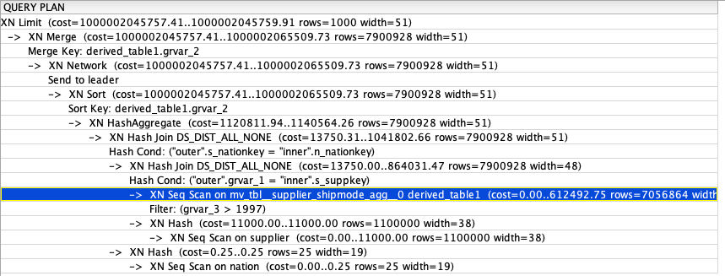

Write additional queries which can leverage your materialized view but which do not directly reference it. For example, Total Extendedprice by Region.

## [2 Stored Procedures](https://catalog.us-east-1.prod.workshops.aws/v2/workshops/9f29cdba-66c0-445e-8cbb-28a092cb5ba7/en-US/lab13" \l "2-stored-procedures)

Stored procedures are commonly used to encapsulate logic for data transformation, data validation, and business-specific logic. By combining multiple SQL steps into a stored procedure, you can reduce round trips between your applications and the database. A stored procedure can incorporate data definition language (DDL) and data manipulation language (DML) in addition to SELECT queries. A stored procedure doesn’t have to return a value. You can use the PL/pgSQL procedural language, including looping and conditional expressions, to control logical flow.

Let’s see how you can create and invoke stored procedure in Redshift. Here our goal is to incrementally refresh the lineitem data. Execute the following query to create lineitem staging table:

create table stage_lineitem (

L_ORDERKEY bigint NOT NULL,

L_PARTKEY bigint,

L_SUPPKEY bigint,

L_LINENUMBER integer NOT NULL,

L_QUANTITY decimal(18,4),

L_EXTENDEDPRICE decimal(18,4),

L_DISCOUNT decimal(18,4),

L_TAX decimal(18,4),

L_RETURNFLAG varchar(1),

L_LINESTATUS varchar(1),

L_SHIPDATE date,

L_COMMITDATE date,

L_RECEIPTDATE date,

L_SHIPINSTRUCT varchar(25),

L_SHIPMODE varchar(10),

L_COMMENT varchar(44));

* Execute below script to create a stored procedure. This stored procedure performs following tasks:

1. Truncate staging table to clean up old data
2. Load data in the stage_lineitem table using the COPY command.
3. Merge updated records in existing lineitem table.

Make sure to replace [Your-Redshift_Role_Arn] value in the script below.

CREATE OR REPLACE PROCEDURE lineitem_incremental()

AS $$

BEGIN

truncate stage_lineitem;

copy stage_lineitem from 's3://redshift-immersionday-labs/data/lineitem-part/l_orderyear=1998/l_ordermonth=8/'

iam_role '[Your-Redshift_Role_Arn]'

region 'us-west-2' gzip delimiter '|' COMPUPDATE PRESET;

delete from lineitem using stage_lineitem

where stage_lineitem.l_orderkey=lineitem.l_orderkey and stage_lineitem.l_linenumber = lineitem.l_linenumber;

insert into lineitem

select * from stage_lineitem;

END;

$$ LANGUAGE plpgsql;

Before you call this stored procedure, capture a metric using the materialized view. We'll compare this value after the stored procedure loads new data to demonstrate the Materialized View auto refresh capability.

1

select SUM(TOTAL_QTY) Total_Qty from supplier_shipmode_agg;

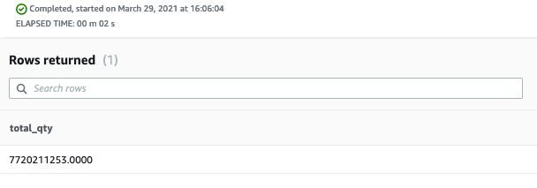

Call this stored procedure using CALL statement. When executed it will perform an incremental load:

call lineitem_incremental();

## [3 Query scheduling](https://catalog.us-east-1.prod.workshops.aws/v2/workshops/9f29cdba-66c0-445e-8cbb-28a092cb5ba7/en-US/lab13" \l "3-query-scheduling)

Amazon Redshift allows you to schedule your SQL queries for executions in recurring schedules. You can now schedule time sensitive or long running queries, loading or unloading your data, stored procedures or refreshing your materialized views on a regular schedule. You can use the Amazon Redshift Console or Amazon Redshift Data API to schedule your SQL queries.

The steps we will complete include the following:

* [Prepare IAM Permissions](https://catalog.us-east-1.prod.workshops.aws/v2/workshops/9f29cdba-66c0-445e-8cbb-28a092cb5ba7/en-US/lab13#prepare-iam-permissions)
* [Schedule your query](https://catalog.us-east-1.prod.workshops.aws/v2/workshops/9f29cdba-66c0-445e-8cbb-28a092cb5ba7/en-US/lab13#schedule-your-query)
* [Monitor your query](https://catalog.us-east-1.prod.workshops.aws/v2/workshops/9f29cdba-66c0-445e-8cbb-28a092cb5ba7/en-US/lab13#monitory-your-query)

### [Prepare IAM Permissions](https://catalog.us-east-1.prod.workshops.aws/v2/workshops/9f29cdba-66c0-445e-8cbb-28a092cb5ba7/en-US/lab13" \l "prepare-iam-permissions)

To schedule queries, the following AWS Identity and Access Management (IAM) configurations will need to be made:

The below steps may have already been completed by your lab administrator, if so you can skip ahead to [Schedule your query](https://catalog.us-east-1.prod.workshops.aws/v2/workshops/9f29cdba-66c0-445e-8cbb-28a092cb5ba7/en-US/lab13#schedule-your-query).

1. An IAM role must be created which can be assumed by the Redshift Scheduler service, Event Bridge and your IAM principle (User or Role). This role will be attached to the schedule and must also be able to retrieve the Redshift credentials needed to execute the query. See [1. Creating a Cluster: Modify IAM Role for Scheduler Access](https://redshift-immersion.workshop.aws/lab1.html#modify-iam-role-for-scheduler-access)
2. Your IAM principle (User or Role) must be modified to be able to assume the above role. If you're logged in as an Admin in your AWS Account, you should already have this privilege. If not, add the following:

Make sure to replace [Your-Redshift_Role_Arn] value in the script below.

{

"Version": "2012-10-17",

"Statement": [

{

"Sid": "AssumeIAMRole",

"Effect": "Allow",

"Action": "sts:AssumeRole",

"Resource": "[Your-Redshift_Role_Arn]"

}

]

}

### [Schedule your query](https://catalog.us-east-1.prod.workshops.aws/v2/workshops/9f29cdba-66c0-445e-8cbb-28a092cb5ba7/en-US/lab13" \l "schedule-your-query)

Navigate, back to Redshift query editor, ensure the query to call your stored procedure is in the editor and click on the Schedule button.

<https://console.aws.amazon.com/redshiftv2/home?#query-editor:>

1

call lineitem_incremental();

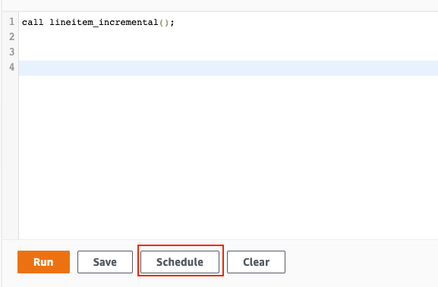

Select IAM Role that you created in previous step. Also, select the cluster, and provide a database name and database user.

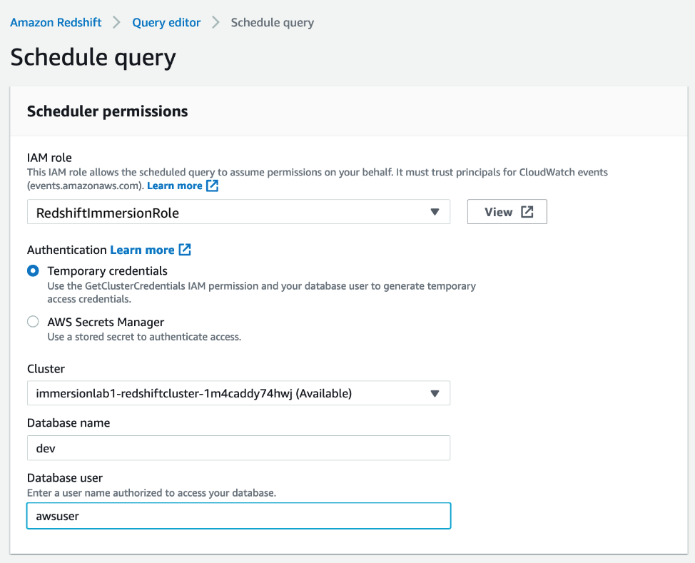

Enter a query name as well as the query text.

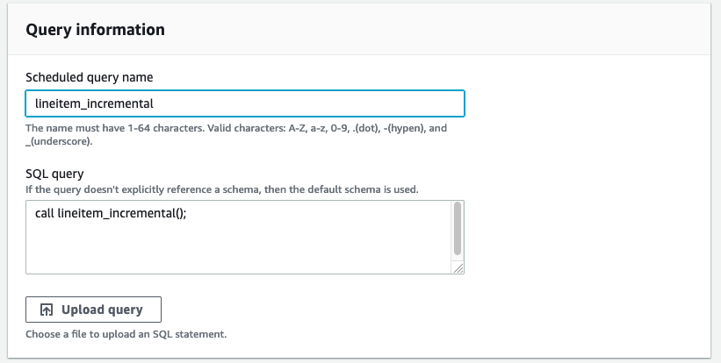

Provide values for Repeat By, Repeat every, and Repeat time. When you select “Repeat at time (UTC)” enter a time that is little later than current time so you can observe the execution. Optionally, you can enable monitoring via Amazon SNS notifications. If you have not enabled SNS for your Redshift cluster, see [Event Subscriptions](https://catalog.us-east-1.prod.workshops.aws/v2/workshops/9f29cdba-66c0-445e-8cbb-28a092cb5ba7/en-US/lab13/lab7.html#event-subscriptions). For this example, we can leave this Disabled.

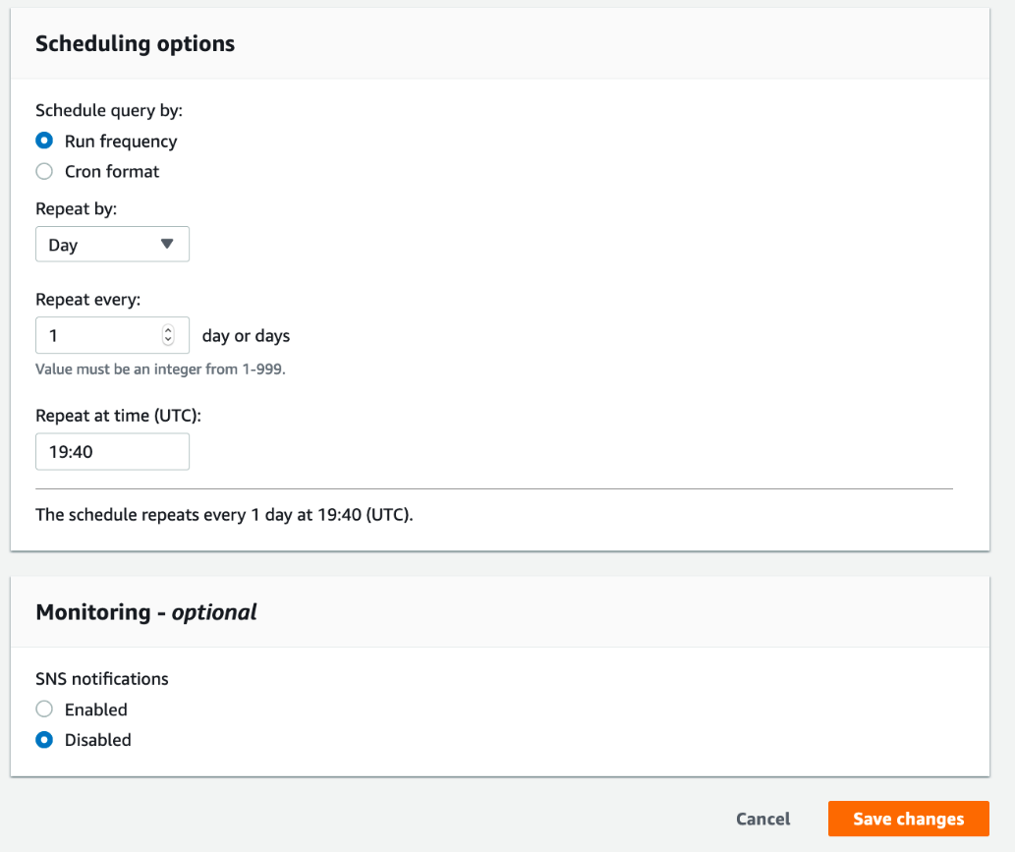

### [Monitor your query](https://catalog.us-east-1.prod.workshops.aws/v2/workshops/9f29cdba-66c0-445e-8cbb-28a092cb5ba7/en-US/lab13" \l "monitor-your-query)

Navigate to the scheduled queries tab and you can see your query scheduler has been created as shown below:

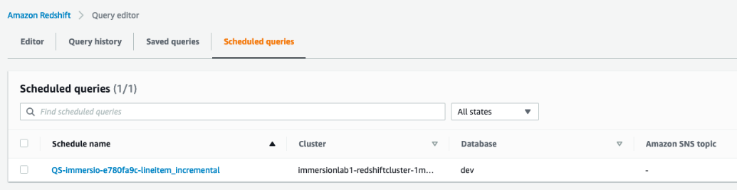

Click on the schedule and after successful execution on scheduled time, you can see the status is “success”.

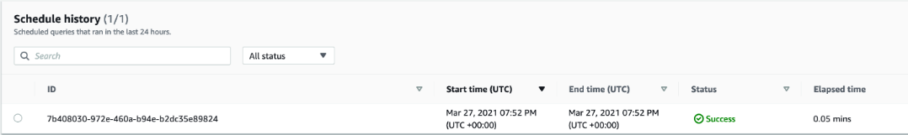

Re-write the stored procedure to pass in parameters for the year and month. Modify your schedule to dynamically get the current year and current month and use those as parameters to your stored procedure.

## [4 Bringing it together](https://catalog.us-east-1.prod.workshops.aws/v2/workshops/9f29cdba-66c0-445e-8cbb-28a092cb5ba7/en-US/lab13" \l "4-bringing-it-together)

Let’s see if Redshift has automatically refreshed materialized view after lineitem table got changed. Note, the materialized view refresh is asynchronous. For this lab, expect ~5min for the data to be refreshed after you called the lineitem_incremental procedure:

1

2

select db_name, userid, schema_name, mv_name, status, refresh_type from SVL_MV_REFRESH_STATUS

where mv_name = 'supplier_shipmode_agg';

The output shows that MV was refreshed automatically and incrementally.

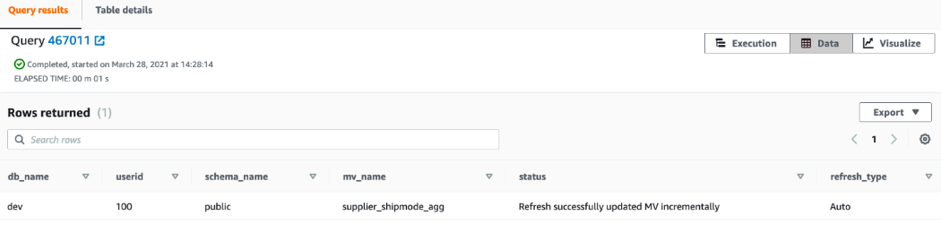

Run the below queries on the MV and compare with the value you had noted previously. You will see SUM has changed which indicates that Redshift has identified changes that have taken place in the base table or tables, and then applied those changes to the materialized view.

1

select SUM(TOTAL_QTY) Total_Qty from supplier_shipmode_agg;

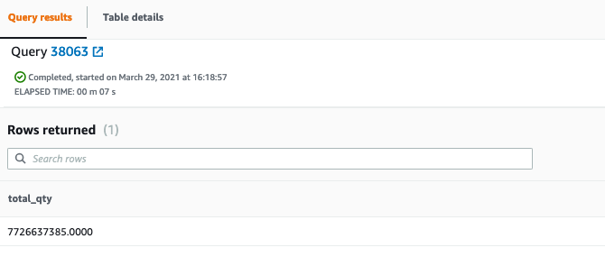

## [Before You Leave](https://catalog.us-east-1.prod.workshops.aws/v2/workshops/9f29cdba-66c0-445e-8cbb-28a092cb5ba7/en-US/lab13" \l "before-you-leave)

If you are done using your cluster, please think about decommissioning it to avoid having to pay for unused resources.

# 14. Data Sharing

In a data warehouse environment, you often have mixed workloads with various user groups and analytics use-cases. While Redshift natively has workload management built with machine learning, there may be situation where critical workloads need to be shielded from unpredictable user behavior. In addition, you may want to cost allocate the analytic spend so each consumer of the data can be responsible for the data they produce as well as the compute they use. Finally, it can be cumbersome to move and manage multiple copies of your data. For all these use cases, Redshift data sharing can be used. This lab demonstrates how you can isolate your workloads by sharing data between 2 Redshift clusters.

## [Contents](https://catalog.us-east-1.prod.workshops.aws/v2/workshops/9f29cdba-66c0-445e-8cbb-28a092cb5ba7/en-US/lab14" \l "contents)

* [Before you Begin](https://catalog.us-east-1.prod.workshops.aws/v2/workshops/9f29cdba-66c0-445e-8cbb-28a092cb5ba7/en-US/lab14#before-you-begin)
* [1 Create a consumer cluster](https://catalog.us-east-1.prod.workshops.aws/v2/workshops/9f29cdba-66c0-445e-8cbb-28a092cb5ba7/en-US/lab14#1-create-a-consumer-cluster)
* [2 Create a data share](https://catalog.us-east-1.prod.workshops.aws/v2/workshops/9f29cdba-66c0-445e-8cbb-28a092cb5ba7/en-US/lab14#2-create-a-data-share)
* [3 Map and query shared data](https://catalog.us-east-1.prod.workshops.aws/v2/workshops/9f29cdba-66c0-445e-8cbb-28a092cb5ba7/en-US/lab14#3-map-and-query-shared-data)
* [Before You Leave](https://catalog.us-east-1.prod.workshops.aws/v2/workshops/9f29cdba-66c0-445e-8cbb-28a092cb5ba7/en-US/lab14#before-you-leave)

## [Before You Begin](https://catalog.us-east-1.prod.workshops.aws/v2/workshops/9f29cdba-66c0-445e-8cbb-28a092cb5ba7/en-US/lab14" \l "before-you-begin)

This lab assumes you have launched a Redshift cluster, configured your client tool, and have loaded it with TPC Benchmark data. If you have not launched a cluster, see [LAB 1 - Creating Redshift Clusters](https://catalog.us-east-1.prod.workshops.aws/v2/workshops/9f29cdba-66c0-445e-8cbb-28a092cb5ba7/en-US/lab1.html). If you have not yet loaded it, see [LAB 2 - Data Loading](https://catalog.us-east-1.prod.workshops.aws/v2/workshops/9f29cdba-66c0-445e-8cbb-28a092cb5ba7/en-US/lab2.html). If you have not configured your client tool, see [Lab 1 - Creating Redshift Clusters : Configure Client Tool](https://catalog.us-east-1.prod.workshops.aws/v2/workshops/9f29cdba-66c0-445e-8cbb-28a092cb5ba7/en-US/lab1.html#configure-client-tool). For this lab, you will need to gather the following information about your cluster from [LAB 1 - Creating Redshift Clusters](https://catalog.us-east-1.prod.workshops.aws/v2/workshops/9f29cdba-66c0-445e-8cbb-28a092cb5ba7/en-US/lab1.html).

Redshift data sharing requires and RA3 node type.

It also assumes you have access to a configured client tool. For more details on configuring SQL Workbench/J as your client tool, see [Lab 1 - Creating Redshift Clusters : Configure Client Tool](https://catalog.us-east-1.prod.workshops.aws/v2/workshops/9f29cdba-66c0-445e-8cbb-28a092cb5ba7/en-US/lab1.html#configure-client-tool). As an alternative you can use the Redshift provided online Query Editor which does not require an installation. <https://console.aws.amazon.com/redshift/home?#query:>

## [1 Create a consumer cluster](https://catalog.us-east-1.prod.workshops.aws/v2/workshops/9f29cdba-66c0-445e-8cbb-28a092cb5ba7/en-US/lab14" \l "1-create-a-consumer-cluster)

Launch a new cluster in the same account & region as the cluster you already have containing the TPC Benchmark data. You can use the instructions found in [LAB 1 - Creating Redshift Clusters](https://catalog.us-east-1.prod.workshops.aws/v2/workshops/9f29cdba-66c0-445e-8cbb-28a092cb5ba7/en-US/lab1.html#launch-redshift-cluster). You can use the same VPC, Subnet Group, Security Group, and IAM Role associated with your original cluster.

Redshift data sharing requires and RA3 node type.

Capture the following information about this new cluster and use it to configure your client tool. For more details on configuring your client tool, see [Lab 1 - Creating Redshift Clusters : Configure Client Tool](https://catalog.us-east-1.prod.workshops.aws/v2/workshops/9f29cdba-66c0-445e-8cbb-28a092cb5ba7/en-US/lab1.html#configure-client-tool).

* [Your-Redshift_Hostname]
* [Your-Redshift_Port]
* [Your-Redshift_Username]
* [Your-Redshift_Password]

After the cluster has been created and you've successfully connected to it, execute the following command and capture the [Consumer-Namespace], you will use this later.

1

select current_namespace;

## [2 Create a data share](https://catalog.us-east-1.prod.workshops.aws/v2/workshops/9f29cdba-66c0-445e-8cbb-28a092cb5ba7/en-US/lab14" \l "2-create-a-data-share)

1. In a new window, connect to the producer cluster with the loaded TPC benchmark data and create a data share containing all tables and grant usage on this data share to the consumer cluster you just created.

Replace the [Consumer-Namespace] with the value you retrieved previously.

CREATE DATASHARE tpc_share SET PUBLICACCESSIBLE TRUE;

ALTER DATASHARE tpc_share ADD SCHEMA public;

ALTER DATASHARE tpc_share ADD ALL TABLES IN SCHEMA public;

GRANT USAGE ON DATASHARE tpc_share TO NAMESPACE '[Consumer-Namespace]';

After the datashare has been created you can validate what datashares exist on the cluster using following commands.

1

show datashares;

You can also use following command to get information on datashares

1

select * from SVV_DATASHARES;

Following command shows what objects datashare contains.

1

select * from svv_datashare_objects;

What happens when new objects are added or removed from the public schema in the producer cluster with the TPC data, will it be automatically reflected in the consumer cluster?

* Add a new table to the public schema. Execute the following statement in producer cluster:

create table public.customer_new (

C_CUSTKEY bigint NOT NULL,

C_NAME varchar(25),

C_ADDRESS varchar(40),

C_NATIONKEY bigint,

C_PHONE varchar(15),

C_ACCTBAL decimal(18,4),

C_MKTSEGMENT varchar(10),

C_COMMENT varchar(117))

diststyle all;

INSERT INTO public.customer_new VALUES (1, 'Customer 1', 'NorthEast'), (2, 'Customer 2', 'SouthEast');

* Check to see if this table was automatically added to the datashare.

select * from svv_datashare_objects where object_name = 'public.customer_new';

* You can explicitly add this new table to datashare using following command:

ALTER DATASHARE tpc_share add TABLE public.customer_new;

1. Let's say you don't want to expose customer details to the consumer cluster, you can also remove a table from the datashare. Execute the following statement:

ALTER DATASHARE tpc_share REMOVE TABLE public.customer;

1. Execute the following command and capture the [TPC-Namespace], you will use later when mapping the datashare to your consumer cluster.

select current_namespace;

## [3 Map and query shared data](https://catalog.us-east-1.prod.workshops.aws/v2/workshops/9f29cdba-66c0-445e-8cbb-28a092cb5ba7/en-US/lab14" \l "3-map-and-query-shared-data)

1. Switching back to the consumer connection, execute the following to create a new database which is connected to the datashare:

Replace the [TPC-Namespace] with the value you retrieved previously.

CREATE DATABASE tpc FROM DATASHARE tpc_share OF NAMESPACE '[TPC-Namespace]';

1. Test querying a table you should have access to and one you don't have access to:

select * from tpc.public.region limit 100;

select * from tpc.public.customer limit 100;

How long does it take for new data to appear in the consumer cluster? Insert a new record in the TPC cluster region table and see if it's available in the consumer cluster.

* In the producer cluster and execute following statement to insert a row into the region table:

insert into public.region values (5, 'New_region','Test Region');

* In the consumer cluster execute the following statement to validate new data is available in region table:

select * from tpc.public.region

where r_name = 'New_region';

1. In addition to [db].[schema].[table] notation, you can map a datashare schema to a local schema:

CREATE EXTERNAL SCHEMA tpc

FROM REDSHIFT DATABASE 'tpc' SCHEMA 'public';

select * from tpc.region limit 100;

select * from tpc.orders limit 100;

What is the resource utilization on the producer cluster with the TPC benchmark data when querying from the consumer cluster?

* Navigate to the Amazon Redshift Console and note the CPU utilization of the producer and consumer clusters.

<https://console.aws.amazon.com/redshiftv2/home?#dashboard>

## [Before You Leave](https://catalog.us-east-1.prod.workshops.aws/v2/workshops/9f29cdba-66c0-445e-8cbb-28a092cb5ba7/en-US/lab14" \l "before-you-leave)

If you are done using your clusters, please think about decommissioning it to avoid having to pay for unused resources.

# 15. Loading & querying semi-structured data

In [8. Querying nested JSON in S3](https://catalog.us-east-1.prod.workshops.aws/v2/workshops/9f29cdba-66c0-445e-8cbb-28a092cb5ba7/en-US/lab15/lab8.html) you learned how to query semi-structured data in S3. In this lab you will learn how to load semi-structured JSON data into Redshift into a single column with the SUPER datatype or by using automatic shredding. You will learn how to this strategy can help with an evolving schema in your semi-structured data.

## [Contents](https://catalog.us-east-1.prod.workshops.aws/v2/workshops/9f29cdba-66c0-445e-8cbb-28a092cb5ba7/en-US/lab15" \l "contents)

* [Before You Begin](https://catalog.us-east-1.prod.workshops.aws/v2/workshops/9f29cdba-66c0-445e-8cbb-28a092cb5ba7/en-US/lab15#before-you-begin)
* [Load JSON data](https://catalog.us-east-1.prod.workshops.aws/v2/workshops/9f29cdba-66c0-445e-8cbb-28a092cb5ba7/en-US/lab15#load-json-data)
* [Unnest the data](https://catalog.us-east-1.prod.workshops.aws/v2/workshops/9f29cdba-66c0-445e-8cbb-28a092cb5ba7/en-US/lab15#unnest-the-data)
* [Load JSON data with shredding](https://catalog.us-east-1.prod.workshops.aws/v2/workshops/9f29cdba-66c0-445e-8cbb-28a092cb5ba7/en-US/lab15#load-json-data-with-shredding)
* [Before You Leave](https://catalog.us-east-1.prod.workshops.aws/v2/workshops/9f29cdba-66c0-445e-8cbb-28a092cb5ba7/en-US/lab15#before-you-leave)

## [Before You Begin](https://catalog.us-east-1.prod.workshops.aws/v2/workshops/9f29cdba-66c0-445e-8cbb-28a092cb5ba7/en-US/lab15" \l "before-you-begin)

This lab assumes you have launched a Redshift cluster, configured your client tool. If you have not launched a cluster, see [LAB 1 - Creating Redshift Clusters](https://catalog.us-east-1.prod.workshops.aws/v2/workshops/9f29cdba-66c0-445e-8cbb-28a092cb5ba7/en-US/lab1.html). If you have not configured your client tool, see [Lab 1 - Creating Redshift Clusters : Configure Client Tool](https://catalog.us-east-1.prod.workshops.aws/v2/workshops/9f29cdba-66c0-445e-8cbb-28a092cb5ba7/en-US/lab1.html#configure-client-tool). For this lab, you will need to gather the following information about your cluster from [LAB 1 - Creating Redshift Clusters](https://catalog.us-east-1.prod.workshops.aws/v2/workshops/9f29cdba-66c0-445e-8cbb-28a092cb5ba7/en-US/lab1.html).

* [Your-Redshift_Role_Arn]

## [Load JSON data](https://catalog.us-east-1.prod.workshops.aws/v2/workshops/9f29cdba-66c0-445e-8cbb-28a092cb5ba7/en-US/lab15" \l "load-json-data)

Assume you have a feed of transaction data landing at the following s3 location. Our goal is to load it in the simplist way possible:

<https://s3.console.aws.amazon.com/s3/buckets/redshift-downloads?region=us-east-1&prefix=semistructured/tpch-nested/data/json/customer_orders_lineitem/&showversions=false>

1. Create a table to store this data without worrying about the schema or underlying structure:

drop table if exists transaction;

create table transaction (

data_json super

);

1. Now, load the data using the COPY statement. Notice the noshred option which will cause the data to be loaded into one field. We will see later how to [Load JSON data with shredding](https://catalog.us-east-1.prod.workshops.aws/v2/workshops/9f29cdba-66c0-445e-8cbb-28a092cb5ba7/en-US/lab15#load-json-data-with-shredding)

Replace the [Your-Redshift_Role_Arn] with the value you retrieved previously.

copy transaction

from 's3://redshift-downloads/semistructured/tpch-nested/data/json/customer_orders_lineitem/customer_order_lineitem.json'

iam_role '[Your-Redshift_Role_Arn]' region 'us-east-1'

json 'noshred';

1. Verify the data has been loaded. Notice the JSON structure. At the top-level you have customer-related attributes.

select * from transaction limit 1;

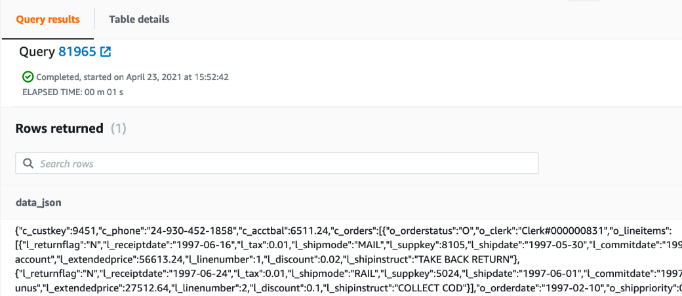

1. Take note of the record count so we can compare the counts between a nested an un-nested data set.

1

select count(1) from transaction;

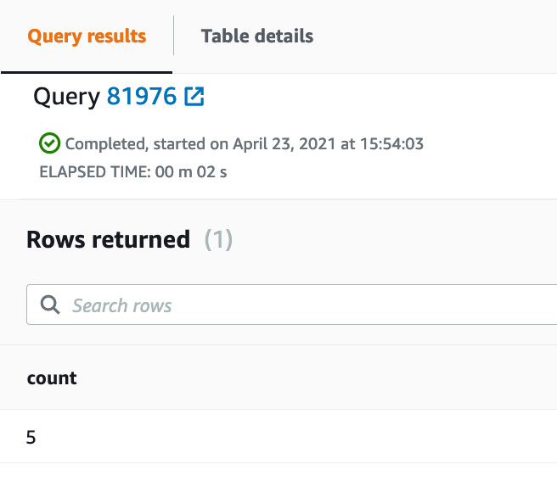

1. Write a query which extracts the customer-related attributes. Since these are at the top-level of JSON structure you should expect a row count that matches the previous row count:

select data_json.c_custkey, data_json.c_phone, data_json.c_acctbal from transaction;

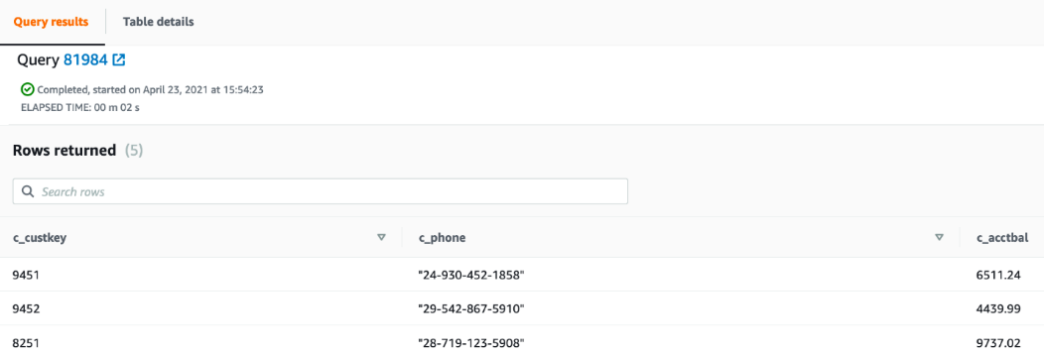

1. Notice that certain fields have double-quote wrappers. This is because Redshift does not enforce types when querying from a SUPER field. This helps with schema evolution to ensure that if the data type changes over time the load process will not fail. See the following documentation to learn more about [dynamic typing](https://docs.aws.amazon.com/redshift/latest/dg/query-super.html#dynamic-typing-lax-processing). Type-cast the extracted fields so they display correctly.

select data_json.c_custkey::int, data_json.c_phone::varchar, data_json.c_acctbal::decimal(18,2) from transaction;

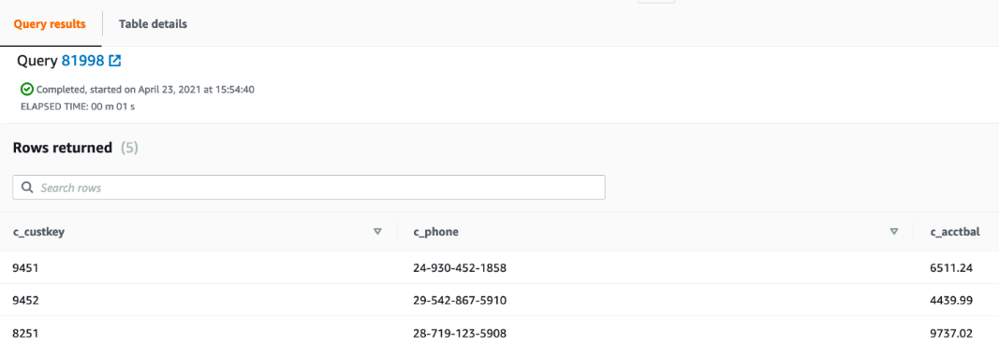

## [Unnest the data](https://catalog.us-east-1.prod.workshops.aws/v2/workshops/9f29cdba-66c0-445e-8cbb-28a092cb5ba7/en-US/lab15" \l "unnest-the-data)

In our use-case you may have noticed that the JSON document contained a c_orders field which was another complex data structure. Furthermore, the c_orders structure contains another nested field. o_lineitems.

1. Write a query which unnests the data. Determine the count of orders and lineitems. Notice that to unnest the data, you leverage the [PartiQL](https://partiql.org/) syntax.

select count(1) from transaction t, t.data_json.c_orders o;

select count(1) from transaction t, t.data_json.c_orders o, o.o_lineitems l;

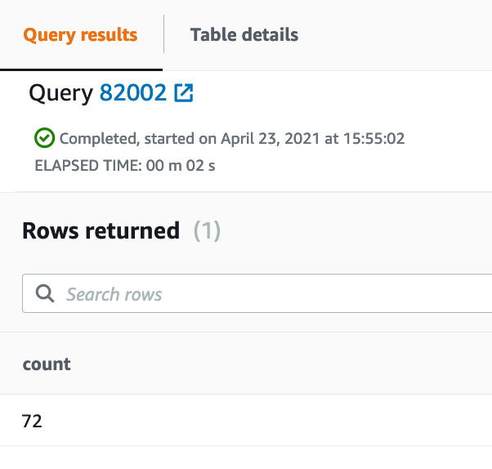

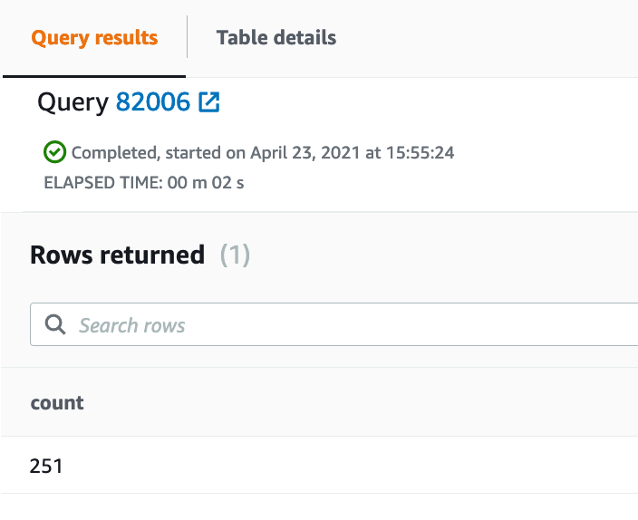

1. To get a full data set of customer, order and lineitem details, execute a query which extracts data from each level in the nested hierarchy.

select data_json.c_custkey::int, data_json.c_phone::varchar, data_json.c_acctbal::decimal(18,2), o.o_orderstatus::varchar, l.l_shipmode::varchar, l.l_extendedprice::decimal(18,2)

from transaction t, t.data_json.c_orders o, o.o_lineitems l;

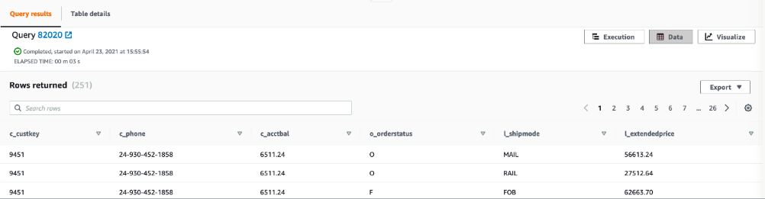

## [Load JSON data with shredding](https://catalog.us-east-1.prod.workshops.aws/v2/workshops/9f29cdba-66c0-445e-8cbb-28a092cb5ba7/en-US/lab15" \l "load-json-data-with-shredding)

In some use-cases the top-level JSON data does not change often and/or your ETL process does not need to incorporate new fields added to the top-level. In these cases, you can use the auto option with option ignorecase parameter to load your JSON data.

1. Create a table that includes the fields from the first level of the JSON document:

drop table if exists transaction_shred;

create table transaction_shred (

c_custkey bigint,

c_phone varchar(20),

c_acctbal decimal(18,2),

c_orders super

);

1. Now, load the data once more using the COPY statement. This time with the auto option which will cause the data to be loaded in fields which match the column names in the JSON objects. The column mapping will use a case-insensitive match based on the ignorecase keyword.

copy transaction_shred from 's3://redshift-downloads/semistructured/tpch-nested/data/json/customer_orders_lineitem/customer_order_lineitem.json'

iam_role '[Your-Redshift_Role_Arn]' region 'us-east-1'

json 'auto ignorecase';

What happens when the table columns do not match the JSON file? Missing a column? Has an extra column? Columns are out of order?

1. Let's get a full data set of customer, order and lineitem details but this time, taking advantage of the fact the first level of the hierarchy has been shredded.

select c_custkey, c_phone, c_acctbal, o.o_orderstatus::varchar, l.l_shipmode::varchar, l.l_extendedprice::decimal(18,2)

from transaction_shred t, t.c_orders o, o.o_lineitems l;

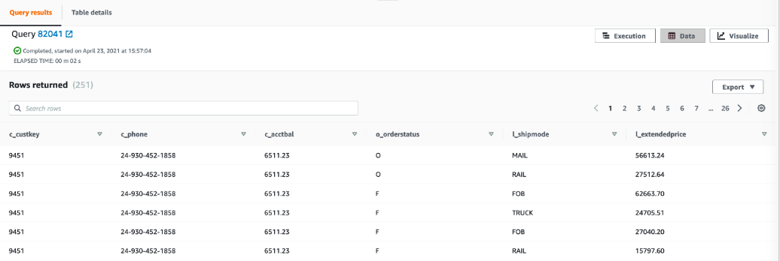

## [Parsing JSON documents to SUPER columns](https://catalog.us-east-1.prod.workshops.aws/v2/workshops/9f29cdba-66c0-445e-8cbb-28a092cb5ba7/en-US/lab15" \l "parsing-json-documents-to-super-columns)

You can insert or update JSON data into a SUPER column using the JSON_PARSE function. This function parses data into JSON format and converts it into the SUPER data type, which you can use in INSERT or UPDATE statements. This includes validating the JSON document in the data.

1. Insert a new customer order in the transaction_shred table.

INSERT INTO transaction_shred VALUES

(1234,

'800-867-5309',

441989.88,

JSON_PARSE(

'[{

"o_orderstatus":"F",

"o_clerk":"Clerk#0000001991",

"o_lineitems":[

{

"l_returnflag":"R",

"l_receiptdate":"2017-07-23",

"l_tax":0.03,

"l_shipmode":"TRUCK",

"l_suppkey":4799,

"l_shipdate":"2014-06-24",

"l_commitdate":"2014-06-05",

"l_partkey":54798,

"l_quantity":4,

"l_linestatus":"F",

"l_comment":"Net new order for new customer",

"l_extendedprice":28007.64,

"l_linenumber":1,

"l_discount":0.02,

"l_shipinstruct":"TAKE BACK RETURN"

}

],

"o_orderdate":"2014-06-01",

"o_shippriority":0,

"o_totalprice":28308.25,

"o_orderkey":1953697,

"o_comment":"wing for 997.1 gt3",

"o_orderpriority":"5-LOW"

}],'));

The Insert errors out because the JSON_PARSE function detects a malformed JSON document.

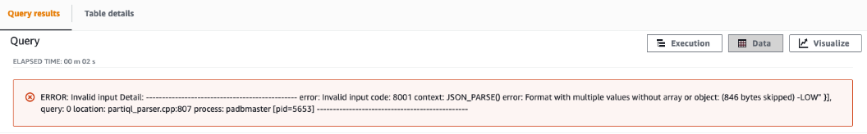

1. Remove the unneeded comma at the end of the JSON and try inserting the data again.

INSERT INTO transaction_shred VALUES

(1234,

'800-867-5309',

441989.88,

JSON_PARSE( '[{

"o_orderstatus":"F",

"o_clerk":"Clerk#0000001991",

"o_lineitems":[

{

"l_returnflag":"R",

"l_receiptdate":"2017-07-23",

"l_tax":0.03,

"l_shipmode":"TRUCK",

"l_suppkey":4799,

"l_shipdate":"2014-06-24",

"l_commitdate":"2014-06-05",

"l_partkey":54798,

"l_quantity":4,

"l_linestatus":"F",

"l_comment":"Net new order for new customer",

"l_extendedprice":28007.64,

"l_linenumber":1,

"l_discount":0.02,

"l_shipinstruct":"TAKE BACK RETURN"

}

],

"o_orderdate":"2014-06-01",

"o_shippriority":0,

"o_totalprice":28308.25,

"o_orderkey":1953697,

"o_comment":"wing for 997.1 gt3",

"o_orderpriority":"5-LOW"

}]'));

1. Next, update the row you just inserted to add a new line item for the order.

If you update a SUPER data column, Amazon Redshift requires the complete document to be passed to column values. Amazon Redshift doesn't support partial update.

update transaction_shred

set c_orders =

JSON_PARSE( '[{

"o_orderstatus":"F",

"o_clerk":"Clerk#0000001991",

"o_lineitems":[

{

"l_returnflag":"R",

"l_receiptdate":"2017-07-23",

"l_tax":0.03,

"l_shipmode":"TRUCK",

"l_suppkey":4799,

"l_shipdate":"2014-06-24",

"l_commitdate":"2014-06-05",

"l_partkey":54798,

"l_quantity":4,

"l_linestatus":"F",

"l_comment":"Net new order for new customer",

"l_extendedprice":28007.64,

"l_linenumber":1,

"l_discount":0.02,

"l_shipinstruct":"TAKE BACK RETURN"

},

{

"l_returnflag":"R",

"l_receiptdate":"2017-07-23",

"l_tax":0.03,

"l_shipmode":"TRUCK",

"l_suppkey":4799,

"l_shipdate":"2014-06-24",

"l_commitdate":"2014-06-05",

"l_partkey":54798,

"l_quantity":4,

"l_linestatus":"F",

"l_comment":"Net new order2 for new customer",

"l_extendedprice":28007.64,

"l_linenumber":2,

"l_discount":0.02,

"l_shipinstruct":"TAKE BACK RETURN"

}

],

"o_orderdate":"2014-06-01",

"o_shippriority":0,

"o_totalprice":28308.25,

"o_orderkey":1953697,

"o_comment":"wing for 997.1 gt3",

"o_orderpriority":"5-LOW"

}]')

where c_custkey = 1234;

1. Finally, let's get a full data set of customer, order and lineitem details.

select c_custkey, c_phone, c_acctbal, o.o_orderstatus::varchar, l.l_shipmode::varchar, l.l_extendedprice::decimal(18,2), l.l_linenumber::int

from transaction_shred t, t.c_orders o, o.o_lineitems l

order by c_custkey;

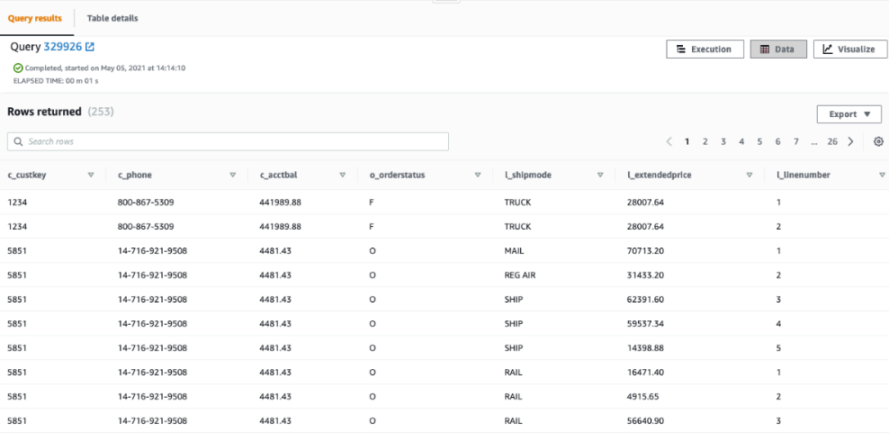

If the JSON_PARSE function is missing in the query, Amazon Redshift treats the value as a single string instead of a JSON-formatted string that must be parsed.

## [Before You Leave](https://catalog.us-east-1.prod.workshops.aws/v2/workshops/9f29cdba-66c0-445e-8cbb-28a092cb5ba7/en-US/lab15" \l "before-you-leave)

If you are done using your cluster, please think about decommissioning it to avoid having to pay for unused resources. For more documentation on ingesting and querying semistructured data in Amazon Redshift refer to the documentation here: [https://docs.aws.amazon.com/redshift/latest/dg/super-overview.htm](https://docs.aws.amazon.com/redshift/latest/dg/super-overview.html)

# 16. Redshift Data API

In this lab you shall learn how to query data via the Redshift Data API. The Amazon Redshift Data API simplifies data access, ingest, and egress from programming languages and platforms supported by the AWS SDK such as Python, Go, Java, Node. js, PHP, Ruby, and C++. We shall be creating Python function in AWS Lambda to interact via Redshift Data API.

The Data API doesn't require a persistent connection to the cluster. Instead, it provides a secure HTTP endpoint and integration with AWS SDKs. You can use the endpoint to run SQL statements without managing connections. Calls to the Data API are asynchronous.

This is a common scenario where customers want to execute queries against a Redshift cluster programmatically without doing Data Sharing or developing Rest APIs.

## [Contents](https://catalog.us-east-1.prod.workshops.aws/v2/workshops/9f29cdba-66c0-445e-8cbb-28a092cb5ba7/en-US/lab16" \l "contents)

* [Contents](https://catalog.us-east-1.prod.workshops.aws/v2/workshops/9f29cdba-66c0-445e-8cbb-28a092cb5ba7/en-US/lab16#contents)
* [Before You Begin](https://catalog.us-east-1.prod.workshops.aws/v2/workshops/9f29cdba-66c0-445e-8cbb-28a092cb5ba7/en-US/lab16#before-you-begin)
* [Prepare IAM permissions](https://catalog.us-east-1.prod.workshops.aws/v2/workshops/9f29cdba-66c0-445e-8cbb-28a092cb5ba7/en-US/lab16#prepare-iam-permissions)
* [Create AWS Lambda function](https://catalog.us-east-1.prod.workshops.aws/v2/workshops/9f29cdba-66c0-445e-8cbb-28a092cb5ba7/en-US/lab16#create-aws-lambda-function)
* [Integrate with API Gateway](https://catalog.us-east-1.prod.workshops.aws/v2/workshops/9f29cdba-66c0-445e-8cbb-28a092cb5ba7/en-US/lab16#integrate-with-api-gateway)
* [Test API in browser](https://catalog.us-east-1.prod.workshops.aws/v2/workshops/9f29cdba-66c0-445e-8cbb-28a092cb5ba7/en-US/lab16#test-api-in-browser)
* [Before You Leave](https://catalog.us-east-1.prod.workshops.aws/v2/workshops/9f29cdba-66c0-445e-8cbb-28a092cb5ba7/en-US/lab16#before-you-leave)

## [Before You Begin](https://catalog.us-east-1.prod.workshops.aws/v2/workshops/9f29cdba-66c0-445e-8cbb-28a092cb5ba7/en-US/lab16" \l "before-you-begin)

This lab assumes you have launched a Redshift cluster, and have loaded it with TPC benchmark data. If you have not launched a cluster, see [LAB 1 - Creating Redshift Clusters](https://catalog.us-east-1.prod.workshops.aws/v2/workshops/9f29cdba-66c0-445e-8cbb-28a092cb5ba7/en-US/lab1.html). If you have not yet loaded it, see [2. Data Loading](https://catalog.us-east-1.prod.workshops.aws/v2/workshops/9f29cdba-66c0-445e-8cbb-28a092cb5ba7/en-US/lab16/lab2.html)

For this lab, you will need to gather the following information about your cluster from [LAB 1 - Creating Redshift Clusters](https://catalog.us-east-1.prod.workshops.aws/v2/workshops/9f29cdba-66c0-445e-8cbb-28a092cb5ba7/en-US/lab1.html).

* [Your-AWS_Account]
* [Your-Redshift_Cluster_Identifier]
* [Your-Redshift_Cluster_Database]
* [Your-Redshift_Cluster_User]

## [Prepare IAM permissions](https://catalog.us-east-1.prod.workshops.aws/v2/workshops/9f29cdba-66c0-445e-8cbb-28a092cb5ba7/en-US/lab16" \l "prepare-iam-permissions)

We need to provide permissions to Lambda to access your Redshift cluster. In the top search bar enter IAM and from results right click and open in new tab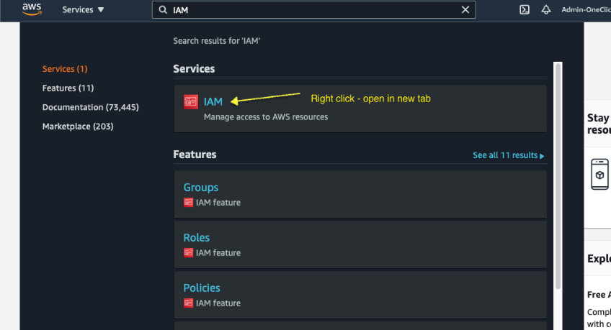

From the left menu choose on Policy and click on Create policy blue button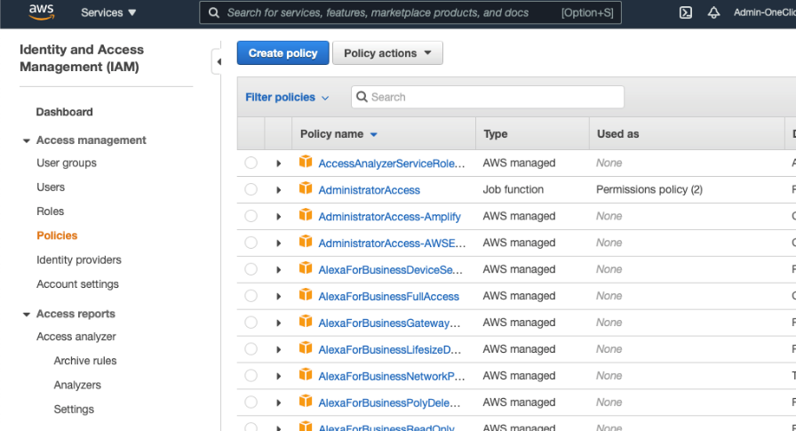

Copy below JSON document to clipboard. These are the necessary privileges to get the redshift cluster credentials, execute the redshift data API.

{

"Version": "2012-10-17",

"Statement": [

{

"Effect": "Allow",

"Action": ["redshift\:GetClusterCredentials"],

"Resource": [

"arn:aws:redshift:*:[AWS_Account]:dbname:[Redshift_Cluster_Identifier]/[Redshift_Cluster_Database]",

"arn:aws:redshift:*:[AWS_Account]:dbuser:[Redshift_Cluster_Identifier]/[Redshift_Cluster_User]"

]

},

{

"Effect": "Allow",

"Action": "redshift-data:*",

"Resource": "*"

}

]

}

Select the JSON tab and replace document below in there. Replace the AWS_Account, the Redshift_Cluster_Identifier, the Redshift_Cluster_Database and the Redshift_Cluster_User with your actual values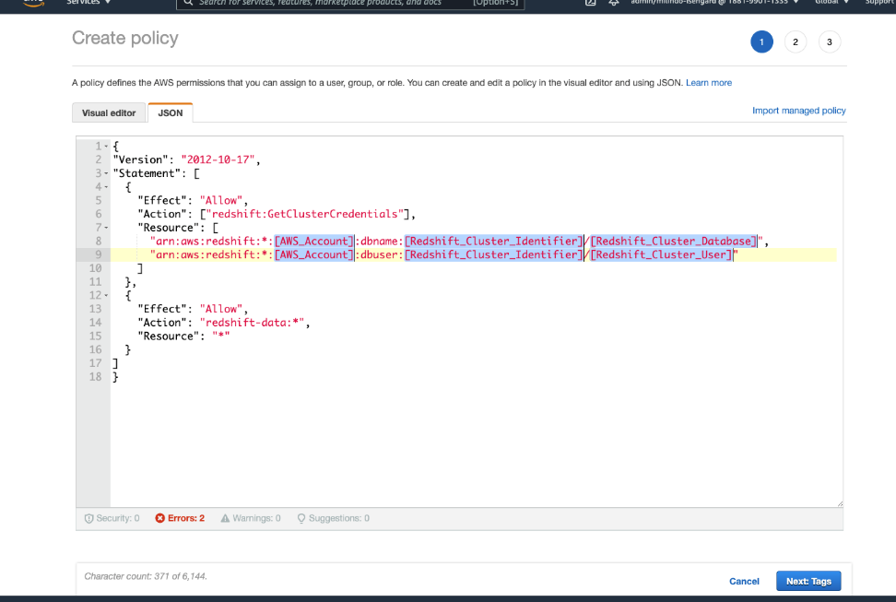

Click next until you reach the final create policy page. Name your policy RedshiftDataAPIPolicy.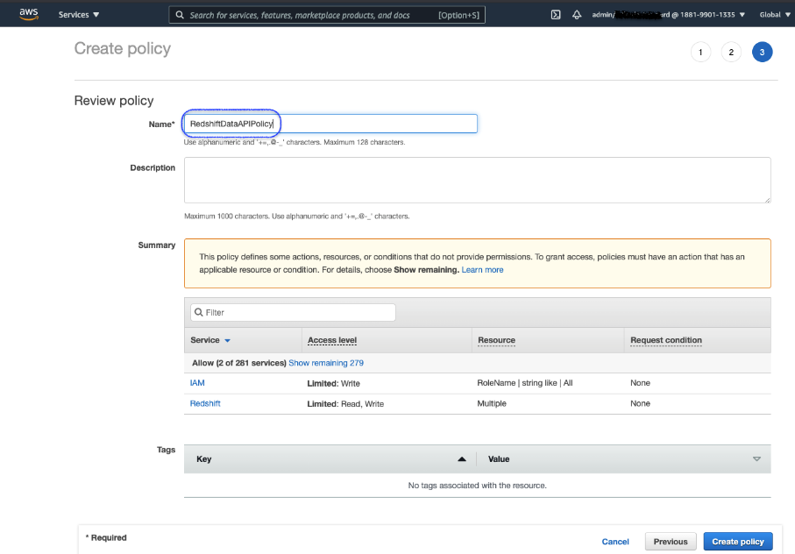

Now lets create a new IAM Role Redshift-data-api-role and attach this policy we just created.

## [Create AWS Lambda function](https://catalog.us-east-1.prod.workshops.aws/v2/workshops/9f29cdba-66c0-445e-8cbb-28a092cb5ba7/en-US/lab16" \l "create-aws-lambda-function)

On the AWS console search for Lambda and open in new tab. Click Create function from right side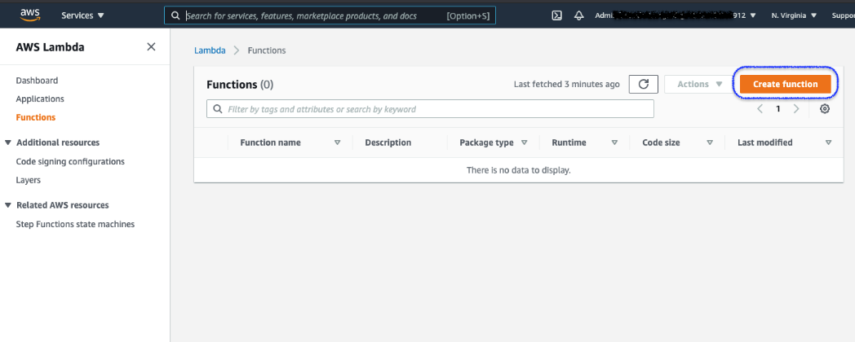

Lets name the function as redshift-data-api-demo and from the Runtime drop down select Python 3.8 or higher whichever latest version shows, toggle the execution role and choose existing role radio button and pick Redshift-data-api-role from the dropdown. Click Create function buttom on bottom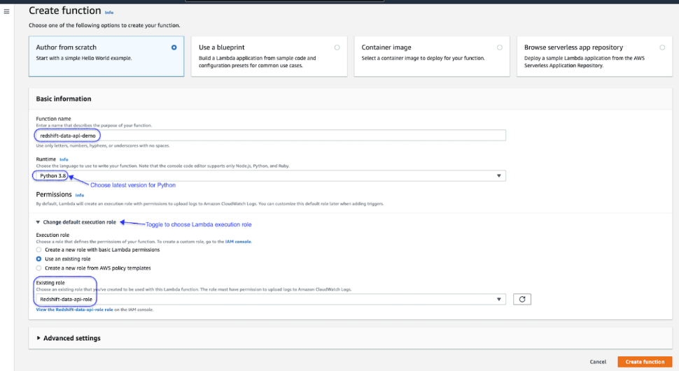

Under the Code cource section , you Double click on the file lambda_function.py which loads the functions code into the editor on the right side panel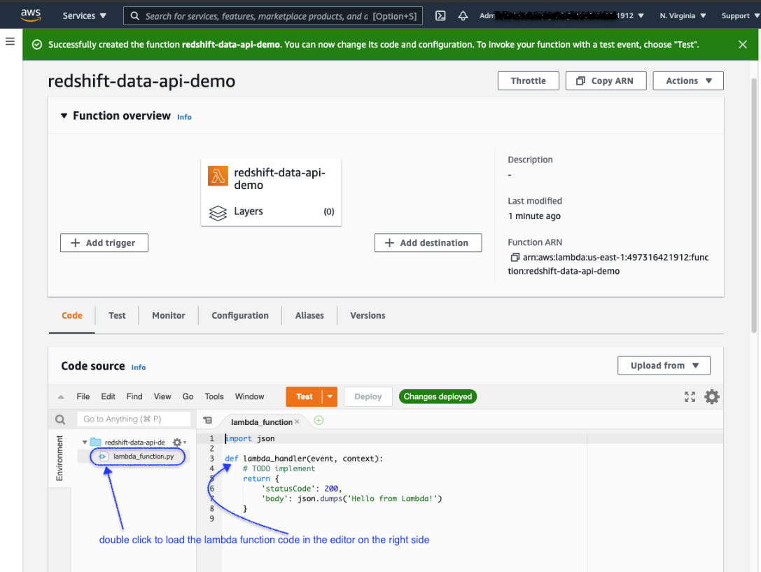

Here you copy-paste the following code to replace the existing code entirely. Click Deploy to save and deploy your functions code

#!/usr/bin/python

# -*- coding: utf-8 -*-

import sys

import os

import boto3

import json

import datetime

# initialize redshift-data client in boto3

redshift_client = boto3.client("redshift-data")

def call_data_api(redshift_client, redshift_database, redshift_user, redshift_cluster_id, sql_statement, with_event=True):

# execute the input SQL statement

api_response = redshift_client.execute_statement(Database=redshift_database, DbUser=redshift_user

,Sql=sql_statement, ClusterIdentifier=redshift_cluster_id, WithEvent=True)

# return the query_id

query_id = api_response["Id"]

return query_id

def check_data_api_status(redshift_client, query_id):

desc = redshift_client.describe_statement(Id=query_id)

status = desc["Status"]

if status == "FAILED":

raise Exception('SQL query failed:' + query_id + ": " + desc["Error"])

return status.strip('"')

def get_api_results(redshift_client, query_id):

response = redshift_client.get_statement_result(Id=query_id)

return response

def lambda_handler(event, context):

redshift_cluster_id = os.environ['redshift_cluster_id']

redshift_database = os.environ['redshift_database']

redshift_user = os.environ['redshift_user']

action = event['queryStringParameters'].get('action')

try:

if action == "execute_report":

country = event['queryStringParameters'].get('country_name')

# sql report query to be submitted

sql_statement = "select c.c_mktsegment as customer_segment,sum(o.o_totalprice) as total_order_price,extract(year from o.o_orderdate) as order_year,extract(month from o.o_orderdate) as order_month,r.r_name as region,n.n_name as country,o.o_orderpriority as order_priority from public.orders o inner join public.customer c on o.o_custkey = c.c_custkey inner join public.nation n on c.c_nationkey = n.n_nationkey inner join public.region r on n.n_regionkey = r.r_regionkey where n.n_name = '"+ country +"' group by 1,3,4,5,6,7 order by 2 desc limit 10"

api_response = call_data_api(redshift_client, redshift_database, redshift_user, redshift_cluster_id, sql_statement)

return_status = 200

return_body = json.dumps(api_response)

elif action == "check_report_status":

# query_id to input for action check_report_status

query_id = event['queryStringParameters'].get('query_id')

# check status of a previously executed query

api_response = check_data_api_status(redshift_client, query_id)

return_status = 200

return_body = json.dumps(api_response)

elif action == "get_report_results":

# query_id to input for action get_report_results

query_id = event['queryStringParameters'].get('query_id')

# get results of a previously executed query

api_response = get_api_results(redshift_client, query_id)

return_status = 200

return_body = json.dumps(api_response)

# total number of rows

nrows=api_response["TotalNumRows"]

# number of columns

ncols=len(api_response["ColumnMetadata"])

print("Number of rows: %d , columns: %d" % (nrows, ncols) )

for record in api_response["Records"]:

print (record)

else:

return_status = 500

return_body = "Invalid Action: " + action

return_headers = {

"Access-Control-Allow-Headers" : "Content-Type",

"Access-Control-Allow-Origin": "*",

"Access-Control-Allow-Methods": "GET"}

return {'statusCode' : return_status,'headers':return_headers,'body' : return_body}

except NameError as error:

raise NameError(error)

except Exception as exception:

error_message = "Encountered exeption on:" + action + ":" + str(exception)

raise Exception(error_message)

We have three different actions this Lambda function supports

1. Execute report : This function calls the Redshift Data API with the provided parameters for redshift client, Database, User, Cluster Identifier and the query statement. The python function call_data_api implements this functionality.
2. Check report status : This functions uses the Redshift Data API to check for previously submitted query statement. Note that along with redshift client the Query Id is required to be passed. The python function check_data_api_status implements this functionality.
3. Get report results : This functions uses the Redshift Data API to retrieve results for a previously submitted query statement. Note that along with redshift client the Query Id is required to be passed. The python function get_api_results implements this functionality.

Select the Configuration tab and create the environment varibles based on your Redshift cluster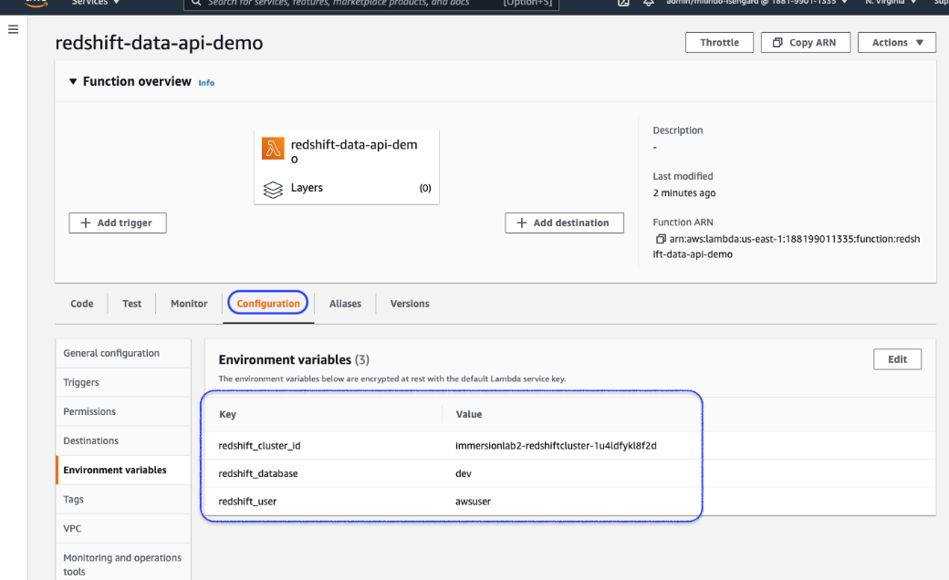

Click Test and select Configure test event. Copy the below JSON input for testing the function. Save event name as EventExecuteReport using below input

{

"queryStringParameters": {

"action": "execute_report",

"country_name": "UNITED STATES"

}

}

Lets create the first test events to fire the report query.

Note that the Lambda function has submitted the query and completed its execution. Redshift Data API executes statements asynchronously so we must circle back for status and results.

Note the query_id returned by the cluster, which we shall use as input to subsequents, EventCheckReport and EventReportResults events we create as below.

Prepare the next test event EventCheckReport

Prepare the next test event EventReportResults using the EventCheckReport as template and replace the action with get_report_results

## [Integrate with API Gateway](https://catalog.us-east-1.prod.workshops.aws/v2/workshops/9f29cdba-66c0-445e-8cbb-28a092cb5ba7/en-US/lab16" \l "integrate-with-api-gateway)

Now that we have successfully tested the functions, let's add this lambda function to an API Gateway so we can query the report over the web browser.

On the AWS console search bar type "API" and open API Gateway in a new tab. At the AWS Gateway console choose the API type as REST API and click Build

Now we define the resources for our API.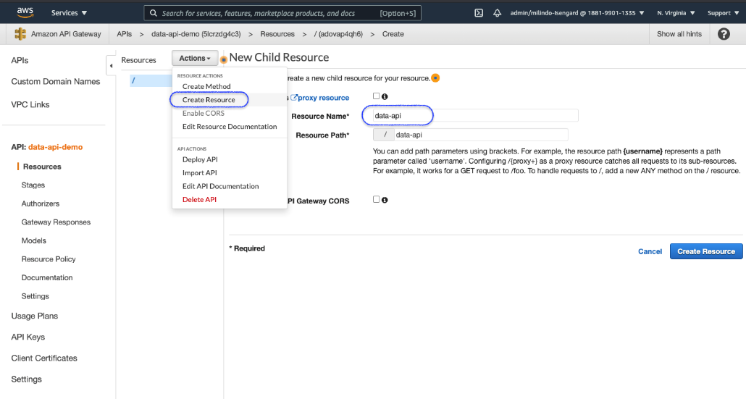

Let's create a GET method on our resource and associate our Lambda function to it.

And finally we deploy our API to gateway and stage it for testing. Stages are used to isolate testing vs production versions of API's.

## [Test API in browser](https://catalog.us-east-1.prod.workshops.aws/v2/workshops/9f29cdba-66c0-445e-8cbb-28a092cb5ba7/en-US/lab16" \l "test-api-in-browser)

Let's now test the API over the gateway via new browser tab or window. But first we need to create a basic HTML page with code to call our API. Copy - paste below into a text editor and save the file as test.html on your desktop.

<html>

<head><meta http-equiv="Access-Control-Allow-Origin" content="*"></head>

<script>

var endpoint;

var counter;

function updateStatus(endpoint, querystring, callback) {

var xhttp = new XMLHttpRequest();

xhttp.onreadystatechange = function() {

if (this.readyState == 4 && this.status == 200) {

callback(this.responseText);

}

};

console.log(endpoint+querystring);

xhttp.open("GET", endpoint+"/"+querystring, true);

xhttp.send();

}

function submitQuery() {

endpoint = document.getElementById('endpoint').value;

var country = document.getElementById('country').value;

querystring = "?action=execute_report&country_name="+country;

updateStatus(endpoint, querystring, function(status){

query_id = status.split('"').join('');

document.getElementById("status").innerHTML = query_id;

querystring = "?action=check_report_status&query_id="+query_id;

counter = 1;

checkStatus(endpoint, querystring, function(){

querystring = "?action=get_report_results&query_id="+query_id;

updateStatus(endpoint, querystring, function(status){

var jsonString = "<pre>" + JSON.stringify(JSON.parse(status),null,2) + "</pre>";

document.getElementById("status").innerHTML = jsonString;

});

});

});

}

function checkStatus(endpoint, querystring, callback) {

updateStatus(endpoint, querystring, function(status){

if (status == "\"FINISHED\"")

callback();

else {

document.getElementById("status").innerHTML = counter + ": " + status;

setTimeout('', 1000);

counter++;

checkStatus(endpoint, querystring, callback)

}

});

}

</script>

<label for=endpoint>Endpoint:</label><input id=endpoint type=text style="width:100%"><br>

<label for=country>Country:</label><input id=country type=text style="width:100%">

<button type="button" onclick=submitQuery()>Submit</button>

<div id=status>

</div>

Now open this test.html in browser. First, enter the Invoke URL from the API Gateway in the Endpoint field. Second, enter a country name , in uppercase example UNITED STATES or CANADA or INDIA and click Submit.

Note the asynchronous nature of the Data API

1. You see the request has been submitted to cluster and the query_id is returned
2. Note the status shows as PICKED, thats when Redshift has picked the report for execution
3. Then status changes to STARTED when Redshift is executing your query
4. Finally status changes to FINISHED and the results are displayed
5. The ColumnMetadata section describes the columns being returned
6. the Records section is the actual data elements from query results



This completes the lab to demonstrate asynchronous query execution in Redshift via the Data API.

## [Before You Leave](https://catalog.us-east-1.prod.workshops.aws/v2/workshops/9f29cdba-66c0-445e-8cbb-28a092cb5ba7/en-US/lab16" \l "before-you-leave)

If you are done using your cluster, please think about decommissioning it to avoid having to pay for unused resources.

For further details, refer to <https://docs.aws.amazon.com/redshift/latest/mgmt/data-api.html>